Jal Rekha

Low Level Design (LLD) Document

Bharosa Module (Factory Testing)
30-JAN-2026



Madhya Pradesh State Electronics Development Cooperation State IT Centre, 47-A, Arera Hills, Bhopal
https://mpsedc.mp.gov.in/

Project: Jal Rekha Water Management System
Module: Bharosa – Factory Testing Details
Organization: Madhya Pradesh Jal Nigam Department
Developed By: MPSeDC
Document Type: Low Level Design (LLD)
Compliance: CMMI DEV Level-5
Version: 1.0

Date: January 2026

Table of Contents
- Introduction
1.1 Purpose of this Document
1.2 Scope
1.3 Target Audience
1.4 References
- System Architecture Overview
2.1 High-Level Architecture Diagram
2.2 Technology Stack
- Module Components & Design
3.1 Component Diagram
3.2 User Interface (UI) Components
3.3 Business Logic Layer
3.4 Data Access Layer
- Database Design
4.1 Entity Relationship (ER) Diagram
4.2 Table Schemas
4.3 Key Relationships and Constraints
- API Design
5.1 API Endpoint Summary
5.2 Detailed API Specifications
- Detailed Process Flow
6.1 Search and Filtering Flow
6.2 Adding New Factory Testing Details Flow
6.3 Data Export Flow
- Sequence Diagrams
7.1 Sequence Diagram: Add New Factory Testing Details
7.2 Sequence Diagram: Search and Export Data
- State Transition Diagram
8.1 Factory Testing Record State
- Class Diagrams
9.1 Core Classes for Factory Testing Module
- Security Considerations
- Performance Considerations
- Introduction

1.1 Purpose of this Document
This Low-Level Design (LLD) document provides a detailed technical blueprint for the development and implementation of the "Factory Testing Details" sub-module within the Bharosa module of the Jal Rekha system. It translates the functional requirements from the User Manual into concrete technical specifications for developers and architects.

1.2 Scope
This document covers the architecture, component design, database schemas, API contracts, and detailed process flows for the features outlined in the User Manual, including:
- Searching and filtering testing records.
- Viewing Factory Testing Survey Inspection Details and Factory Testing Details.
- Adding new factory testing records.
- Exporting data to Excel.

1.3 Target Audience
- Software Developers
- System Architects
- Database Administrators
- Quality Assurance Teams
- Project Managers

1.4 References
- Document A: Jal Rekha - Bharosa Module - Factory Testing Details User Manual (v1.0)
- Document B: Jal Rekha - System Requirements Specification (SRS)
- Document C: Jal Rekha - API Style Guide

- System Architecture Overview
The Factory Testing Details module follows a standard 3-tier architecture, ensuring separation of concerns, scalability, and maintainability.

2.1 High-Level Architecture Diagram
The diagram below illustrates how the presentation, business, and data layers interact.

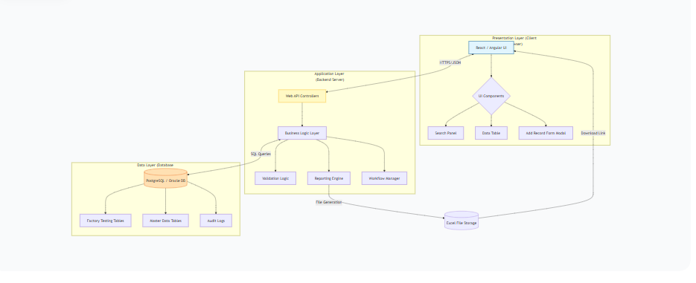

2.2 Technology Stack
- Frontend: React.js or Angular with TypeScript. Use of component libraries (e.g., Material-UI, Ant Design) for UI elements like dropdowns, tables, and modals.
- Backend: Java (Spring Boot) or .NET Core (C#). RESTful API architecture.
- Database: Relational Database (e.g., PostgreSQL, Oracle, MySQL).
- Reporting: Library for Excel generation (e.g., Apache POI, EPPlus).
- Authentication/Authorization: OAuth 2.0 / JWT (JSON Web Tokens) based mechanism.

3. Module Components & Design

3.1 Component Diagram
This diagram breaks down the sub-module into its key functional components.

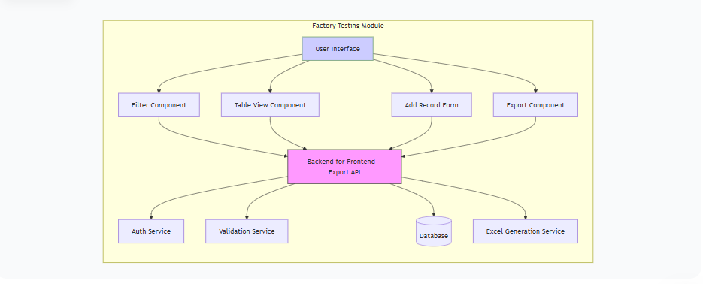
3.2 User Interface (UI) Components

- SearchFilterComponent:
  - Purpose: Renders the cascading dropdowns (PIU, Scheme, Component, Sub-Component) and the search/clear buttons.
  - Logic: On selecting a parent dropdown (e.g., PIU), it triggers an API call to fetch the relevant child options (e.g., Schemes). It maintains the state of selected filters.

- DataTableComponent:
  - Purpose: Displays the list of records in a paginated, sortable table. It receives data as props from a parent component.
  - Features: Server-side pagination, column sorting, and a client-side text search box for filtering the currently loaded data.

- AddRecordModalComponent:
  - Purpose: A modal dialog containing a dynamic form for creating a new factory testing record. It also uses cascading dropdowns for data consistency.
  - Logic: On submission, it sends a POST request to the backend. It handles validation errors returned from the API.

- ExportButtonComponent:
  - Purpose: A button that triggers the data export process. It may present a small modal to confirm the export scope (current page vs. all results).

3.3 Business Logic Layer
- FilterService: Handles the logic for cascading filters, fetching master data based on user context and selections.
- TestingRecordService: Contains the core logic for CRUD operations. For adding a record, it validates the logical relationship between selected entities (e.g., ensuring the vendor is empanelled for that component).
- ExportService: Manages the export process. It applies the same filters used in the UI search to a query, fetches all relevant data, and hands it to the ExcelGenerator.
- ExcelGenerator: A utility class that takes a list of data objects and transforms them into a formatted .xlsx file.

3.4 Data Access Layer
- Repositories/DAOs:
  - FactoryTestingDetailsRepository: Handles database operations for the ftd_records table.
  - FactoryTestingSurveyRepository: Handles database operations for the ftsi_records table.
  - MasterDataRepository: Generic or specific repositories to fetch data from lookup tables (PIU, Scheme, Vendor, etc.).

- Entities/Models: Plain Old Java Objects (POJOs) or C# classes that map directly to database tables.

4. Database Design
4.1 Entity Relationship (ER) Diagram
The diagram shows the core tables and their relationships.

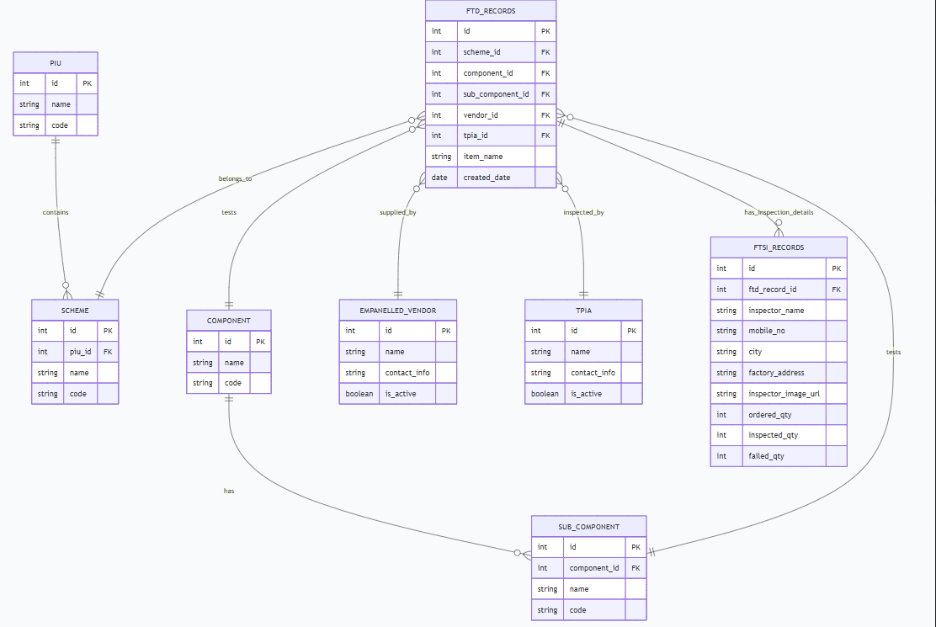

4.2 Table Schemas
1. piu_master (Project Implementation Unit)

Column Name | Data Type | Constraints | Description
id | INT/BIGINT | PRIMARY KEY, AUTO_INCREMENT | Unique identifier
name | VARCHAR(255) | NOT NULL | Name of the PIU (e.g., Bhopal)
code | VARCHAR(50) | UNIQUE | Official code for the PIU
is_active | BOOLEAN | DEFAULT TRUE | Soft delete flag

- scheme_master (Water Supply Scheme)

Column Name | Data Type | Constraints | Description
id | INT/BIGINT | PRIMARY KEY, AUTO_INCREMENT | Unique identifier
piu_id | INT/BIGINT | FOREIGN KEY (piu_master.id) | The PIU this scheme belongs to
name | VARCHAR(255) | NOT NULL | Name of the scheme (e.g., Damedhi-1)
code | VARCHAR(50) | UNIQUE | Official scheme code

- component_master (Component Type)

Column Name | Data Type | Constraints | Description
id | INT/BIGINT | PRIMARY KEY, AUTO_INCREMENT | Unique identifier
name | VARCHAR(255) | NOT NULL | Name (e.g., INTAKE WELL, WTP)

4. sub_component_master (Sub-Component Type)
Column Name | Data Type | Constraints | Description
id | INT/BIGINT | PRIMARY KEY, AUTO_INCREMENT | Unique identifier
component_id | INT/BIGINT | FOREIGN KEY (component_master.id) | The parent component
name | VARCHAR(255) | NOT NULL | Name (e.g., Filter House, DI Pipes)

5. empanelled_vendor_master
Column Name | Data Type | Constraints | Description
id | INT/BIGINT | PRIMARY KEY, AUTO_INCREMENT | Unique identifier
name | VARCHAR(255) | NOT NULL | Vendor name (e.g., Alpha, Switzer)
contact_info | TEXT |  | Address, phone, etc.
is_active | BOOLEAN | DEFAULT TRUE | Status of vendor empanelment

- tpia_master (Third Party Inspection Agency)

Column Name | Data Type | Constraints | Description
id | INT/BIGINT | PRIMARY KEY, AUTO_INCREMENT | Unique identifier
name | VARCHAR(255) | NOT NULL | Agency name
contact_info | TEXT
is_active | BOOLEAN | DEFAULT TRUE | Status of agency

7. ftd_records (Factory Testing Details)
Column Name | Data Type | Constraints | Description
id | INT/BIGINT | PRIMARY KEY, AUTO_INCREMENT | Unique identifier
scheme_id | INT/BIGINT | FOREIGN KEY (scheme_master.id)
component_id | INT/BIGINT | FOREIGN KEY (component_master.id)
sub_component_id | INT/BIGINT | FOREIGN KEY (sub_component_master.id)
item_name | VARCHAR(255) | NOT NULL
vendor_id | INT/BIGINT | FOREIGN KEY (empanelled_vendor_master.id)
tpia_id | INT/BIGINT | FOREIGN KEY (tpia_master.id)
created_by | INT/BIGINT | FOREIGN KEY (user.id) | User who created the record
created_date | TIMESTAMP | DEFAULT CURRENT_TIMESTAMP
is_active | BOOLEAN | DEFAULT TRUE | Soft delete

8. ftsi_records (Factory Testing Survey Inspection)
Column Name | Data Type | Constraints | Description
id | INT/BIGINT | PRIMARY KEY, AUTO_INCREMENT | Unique identifier
ftd_record_id | INT/BIGINT | FOREIGN KEY (ftd_records.id) | Link to the main testing record
inspector_name | VARCHAR(255) | NOT NULL
mobile_no | VARCHAR(20)
city | VARCHAR(100)
factory_address | TEXT
inspector_image_url | TEXT |  | URL/path to uploaded image
ordered_qty | INT | NOT NULL, DEFAULT 0
inspected_qty | INT | NOT NULL, DEFAULT 0
failed_qty | INT | NOT NULL, DEFAULT 0
created_date | TIMESTAMP | DEFAULT CURRENT_TIMESTAMP

4.3 Key Relationships and Constraints
- Cascading Filters: The relationship piu_master.id -> scheme_master.piu_id enables the cascading dropdowns.
- Data Integrity: Foreign keys ensure that a record cannot reference a non-existent PIU, Scheme, or Vendor.
- Business Rule: The backend must enforce that inspected_qty cannot be greater than ordered_qty, and failed_qty cannot be greater than inspected_qty.

5. API Design
5.1 API Endpoint Summary
Method | Endpoint | Description
GET | /api/piu | Get list of all active PIUs
GET | /api/filters/scheme?piuId={id} | Get schemes for a given PIU
GET | /api/filters/component | Get all components
GET | /api/filters/sub-component?componentId={id} | Get sub-components for a given component
GET | /api/ftd/records | Get paginated list of Factory Testing records
POST | /api/ftd/records | Create a new Factory Testing record
GET | /api/ftd/export | Export filtered Factory Testing data to Excel

5.2 Detailed API Specifications
GET /api/ftd/records
- Description: Fetches a paginated, filtered list of Factory Testing records, joining data from ftd_records and ftsi_records as needed.
- Query Parameters:
  - piuId (optional): Filter by PIU ID.
  - schemeId (optional): Filter by Scheme ID.
  - componentId (optional): Filter by Component ID.
  - subComponentId (optional): Filter by Sub-Component ID.
  - page (optional, default: 0): Page number for pagination.
  - size (optional, default: 50): Number of records per page.
  - sortBy (optional, default: createdDate): Field to sort by.
  - sortDirection (optional, default: desc): Sort direction (asc or desc).
- Success Response (200 OK):

json
{
"content": [
{
"id": 123,
"schemeName": "Damedhi-1",
"componentName": "INTAKE WELL",
"subComponentName": "Cranes/Gantry Girders",
"itemName": "EOT Crane",
"vendorName": "Alpha",
"tpiaName": "TPIA Solutions Ltd.",
"inspectorName": "Rajesh Sharma",
"mobileNo": "9876543210",
"city": "Indore",
"factoryAddress": "Industrial Area, Indore",
"orderedQty": 2,
"inspectedQty": 2,
"failedQty": 0,
"createdDate": "2025-11-20T10:30:00Z"
}
],
"page": 0,
"size": 50,
"totalElements": 150,
"totalPages": 3
}

POST /api/
- Description: Creates a new Factory Testing record.
- Request Body:
json
{
"schemeId": 101,
"componentId": 5,
"subComponentId": 25,
"itemName": "Flow Sensor",
"vendorId": 3,
"tpiaId": 2
}

- Validation Rules:
  - All fields are mandatory.
  - The schemeId must belong to an active scheme.
  - The vendorId must correspond to an active, empanelled vendor.
- Success Response (201 Created): Returns the newly created record object, including its id.
GET /api/ftd/export
- Description: Triggers an export of data to an Excel file.
- Query Parameters: Accepts the same filter parameters as GET /api/ftd/records (piuId, schemeId, componentId, subComponentId).
- Response: This is typically a file download. The response headers should include Content-Type: application/vnd.openxmlformats-officedocument.spreadsheetml.sheet and Content-Disposition: attachment; filename="factory_testing_report.xlsx".

6. Detailed Process Flow
6.1 Search and Filtering Flow
- User Action: User selects a PIU from the first dropdown.
- Frontend: The SearchFilterComponent captures the piuId and makes an AJAX call to GET /api/filters/scheme?piuId={id}.
- Backend: The controller fetches the list of schemes for that PIU from the database and returns them as JSON.
- Frontend: The SearchFilterComponent populates the Scheme dropdown with the results. This process repeats for Component and Sub-Component.
- User Action: User clicks the "Search" button.
- Frontend: The DataTableComponent sends a request to GET /api/ftd/records with all selected filter values as query parameters.
- Backend: The TestingRecordService builds a dynamic query based on the provided parameters, applies pagination and sorting, and fetches data from the database.
- Frontend: The DataTableComponent receives the paginated data and renders the table. The user can then use the local text search box to filter the rows currently loaded in the browser.
6.2 Adding New Factory Testing Details Flow
- User Action: User clicks the "Add Factory Details" button.
- Frontend: The AddRecordModalComponent is rendered. It loads the necessary master data (e.g., list of components, vendors) via API calls.
- User Action: User fills in the mandatory fields. The form may provide client-side validation (e.g., required fields not empty).
- User Action: User clicks "SUBMIT".
- Frontend: The component constructs a JSON payload and sends a POST request to /api/ftd/records.
- Backend:
  - The ValidationService checks for mandatory fields and logical consistency (e.g., vendor empanelment).
  - If validation passes, the TestingRecordService creates a new record in the ftd_records table.
  - An entry is made in an audit log.
- Backend Response: Sends a 201 Created status with the new record's data.
- Frontend: On success, the modal closes, and the DataTableComponent refreshes its data (e.g., by re-fetching the first page) to show the newly added record.
6.3 Data Export Flow
- User Action: After applying filters, the user clicks the "Export to Excel" button.
- Frontend: The ExportButtonComponent sends a request to GET /api/ftd/export, passing the current filter criteria. It may set the Accept header to request the file directly.
- Backend:
  - The ExportService receives the request and passes the filters to the TestingRecordService.
  - TestingRecordService fetches all records matching the criteria (pagination is ignored for export).
  - The list of records is passed to the ExcelGenerator, which creates an .xlsx file in memory or a temporary storage location.
  - The HTTP response is crafted with the file as the body and appropriate headers for a file download.
- Frontend: The browser receives the response and initiates a file download, saving the factory_testing_report.xlsx to the user's local machine.

7. Sequence Diagrams
7.1 Sequence Diagram: Add New Factory Testing Details
This diagram illustrates the interaction between components during the record creation process.
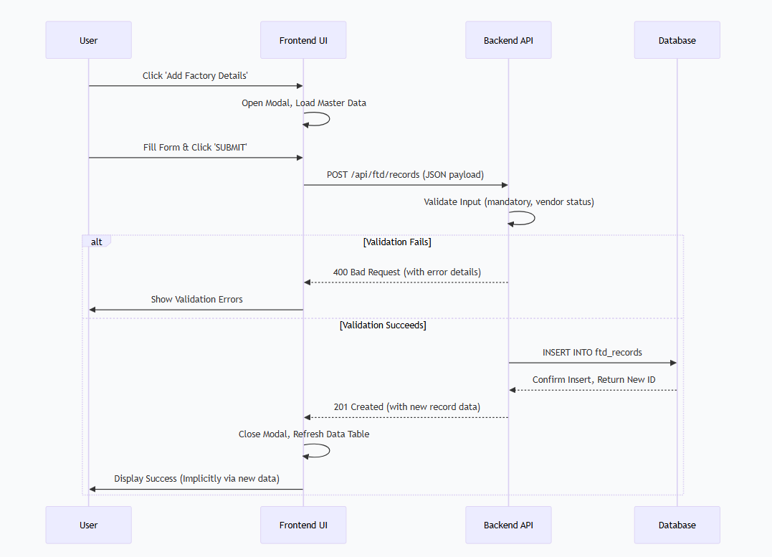

7.2 Sequence Diagram: Search and Export Data
This diagram illustrates the interaction for a filtered export.

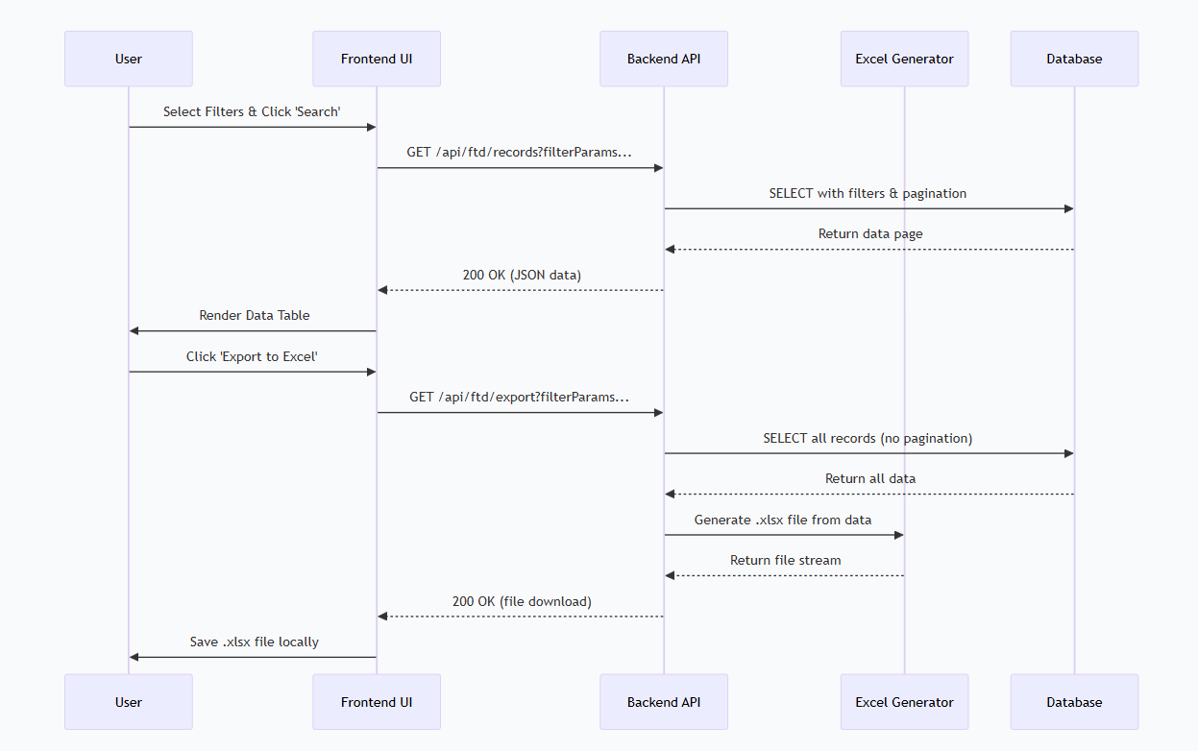

8. State Transition Diagram
8.1 Factory Testing Record State
While the current user manual implies a simple creation state, a robust system would track a lifecycle. This diagram models a potential state machine for a FTD Record.
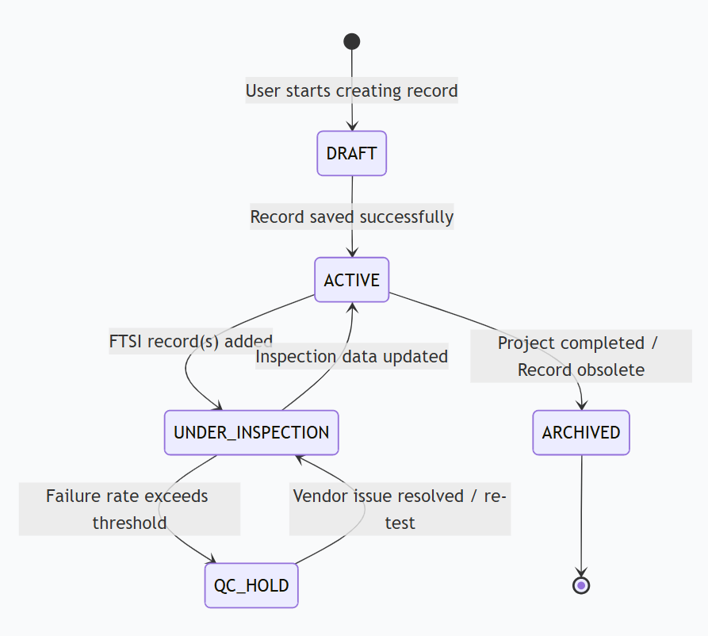
- DRAFT: Initial state, data not fully saved.
- ACTIVE: The record is created and linked to a vendor and TPIA, ready for inspection.
- UNDER_INSPECTION: One or more FTSI Records have been linked, indicating ongoing testing.
- QC_HOLD: A business rule (e.g., failed_qty / inspected_qty > 0.2) has automatically flagged the record for review.
- ARCHIVED: The record is no longer active but retained for compliance.
- Class Diagrams

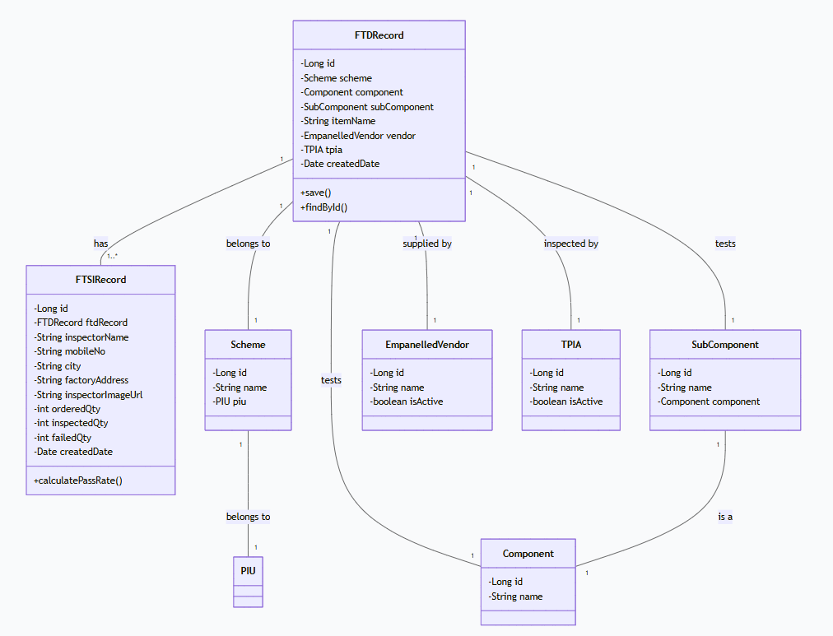
9.1 Core Classes for Factory Testing Module
A simplified UML class diagram showing the core entities and their relationships in the backend

10. Security Considerations
- Authentication: All API endpoints must be protected by a JWT or session-based authentication mechanism. The User context is crucial for created_by and audit logs.
- Authorization: Role-Based Access Control (RBAC) must be implemented. For example, a TPIA Coordinator role may have permission to add records, while a Viewer role can only search and export. These permissions should be checked in the API controllers.
- Input Validation: All inputs, especially in POST and GET parameters, must be validated and sanitized on the backend to prevent SQL Injection and Cross-Site Scripting (XSS) attacks.
- Data Masking: Sensitive information like mobile numbers might be partially masked for users with lower privilege levels.
- Audit Logging: All create, update, and delete operations on FTD and FTSI records should be logged with user ID, timestamp, and the action performed for compliance (CMMI Level 5).
11. Performance Considerations
- Database Indexing: Create indexes on foreign key columns (scheme_id, vendor_id, etc.) and columns used in WHERE clauses (created_date) to speed up search queries.
- Pagination: The GET /api/ftd/records API must enforce server-side pagination to prevent loading thousands of records at once, which would degrade performance.
- Cascading Dropdowns: API responses for master data (PIU, Schemes, etc.) should be cached on the client-side or via a CDN to reduce server load, as this data changes infrequently.
- Asynchronous Export: For very large exports, consider making the export process asynchronous. The initial request would return a 202 Accepted with a job ID. The frontend could then poll a status endpoint, and the user would be notified when the file is ready for download.

